DART
COMPLETE GUIDELINE
FIRST EDITION

AUTHOR
MOHAMMAD SANJID DAD

Guide you to be a complete developer
About the Author

Hello there, this is Mohammad Sanjid Dad an Undergraduate Student B.Sc. in CSE at RSTU Known as Rajshahi Science & Technology University. I’m passionate about software development, problem-solving, & contributing to collaborative projects that create real-world impact.
Over the past few years, I’ve dedicated more than 10,000 Hours to learning, building software, and strengthening my understanding of core programming concepts.
I prefer meaningful and efficient work, and I dislike repeating the same tasks unnecessarily, which drives me to automate, optimize, and improve workflows wherever possible.
Free time, I enjoy playing Football and Badminton, which help me stay focused and energized.
I live in Natore, Bangladesh, a culturally rich place known for its Famous Kacha Golla sweet and Patul, Often called the “Mini Cox’s Bazar.” I’m proud to be the youngest son in the Dad Family. My Mother is a dedicated Homemaker, and my Father is a Businessman who has always supported my academic and personal growth.

Contents
Chapter 1: Dart Fundamentals ……………………………………………………………………………………………… 7
1.1 Variables ………………………………………………………………………………………….…………… 7
1.2 Functions ……………………………………………………………………………………………………… 7
1.2.1 Arrow Functions ……………………..…………………………………………………….………… 8
1.2.2 Lambdas Functions ………………..…………………………………………………………………8
1.3 Controls Flow ………………………………………………………………………………………………… 9
1.4 Dart Collections ……………………………………………………………………………………………… 9
1.4.1 List Declare and Creating …………………………...……………………………………………… 9
1.4.2 Map Declare and Creating ……………………………………………………………….……….. 10
1.4.3 Dart Query ………………………………………………………...……………………….………… 11
1.5 Null Safety …………………………………………………………………………………………………... 11
1.6 String Interpolation ……………………………………………………..……………………..………… 12
1.7 Exception Handling ……………………………………………………………………………..………… 13
1.7.1 Throwing My Own Exception or Custom Exceptions ……………………………..………… 14

Chapter 2: Dart Object Oriented Programming ………………………..……………..…………………….………… 16
2.1 Dart Class & Objects ………………………..……………..…………………………………...………… 16
2.2 Class Constructors ………….…………………..……………..……………………………….………… 16
2.2.1 Default Constructors ……………..……………..……..……………………………...………… 16
2.2.1.1 Implicit Default Constructors …………………..……………………………………..…..… 17
2.2.1.2 Explicit Default Constructors ………………………..……………………………..……..… 17
2.2.2 Parameterized Constructors ……………………………………………..………..… 18
2.2.3 Named Constructors …………………………………………..………………..…..… 20
2.2.4 Const Constructors ………………………………………………..……………….…… 21
2.2.5 Factory Constructors …………………………………………..………………….….. 22
2.2.5.1 Cached Factory Constructors ………………………………………………. 22
2.2.6 Redirecting Constructors …………………………………………………………..… 24
2.3 Class Inheritance ……………………………………………………………………………………..…... 24
2.3.1 Parent Class Constructors Inheritance By Super Class ..……………………………….…. 25
2.4 This, Static and Method Overriding In Dart …………………………………………………….…… 26
2.4.1 Method Overriding ………………………………………………………………………………… 26
2.4.2 This keyword In Dart …………………………………………………………………….……….. 27
2.4.2 Static keyword In Dart ……………………………………………..……………………..…….. 27
2.5 Abstract Class & Inheritances ………………………………………….……….……………………… 28
2.6 Mixins In Dart ………………………………………...………………………………………………..….. 31
2.7 Getters and Setters ……………………………………………………………………………………..… 33

Chapter 3: Advanced Dart Programming ………………………..……………..……...…………………….………… 35
3.1 Asynchronous Programming ………………………………………………………………..………….. 35
3.1.1 Future In Dart ……………………………………………………..……………………..………….. 35
3.1.2 Async In Dart ………………………………………………………..…………………..………….. 36
3.1.3 Await In Dart …………………………………………………………..………………..………….. 38
3.2 Generics In Dart …………………………………………………………….……………………………… 38
3.2.1 What Are Generics ……………………………………………………..………………………….. 38
3.3 Extensions In Dart …………………………………………………………….………………………….. 40
3.4 Typedefs In Dart ………………………………………………………………………..…………………. 41
3.5 Enums In Dart …………………………………………………….……………………………………….. 42
3.5.1 Advanced Enums In Dart ………………………………………….…………………………….. 44
3.6 Cascading Notation In Dart ……………………………………….…..……………...……………….. 46
3.7 Tear – Off Syntax In Dart ………………………………………………………..…………………….. 48
3.8 Null – Awareness Operators & Spread Operators In Dart ……………….…………………….. 49
3.8.1.1 IF – Null Operators …………………………………………………………………………….. 49
3.8.1.2 Null – Aware Access Operators ……………………………………………………..…….. 49
3.8.1.3 IF – Null Assignment Operators ………………………………………………….……….. 50
3.8.1.4 IF – Null Assertion Operators …………………………………………………….……….. 50
3.8.2 Spread Operators In Dart ……………………………….…………………. 50

Chapter 4: Dart Functional Programming …..…………………..…………….……...…………………….………… 52
4.1 Anonymous Function / Lambdas Functions ………………………………………………………… 52
4.2 Higher – Order Functions In Dart …………………………………………………………………….. 52
4.2.1 Takes Another Function As A Parameters In Dart ……………………………………..…. 52
4.2.2 Return Functions As Its Result In Dart ……………………………………………………… 53
4.3 Closures In dart ……………………………….…………………………………………………………… 54
4.4 Collections Method In Dart Programming ………………………………………………………….. 55
4.4.1 Lists Methods In Dart …………………………………………………………………………….. 55
4.4.2 Sets Methods In Dart …………………………………………………………………………….. 56
4.4.3 Maps Methods In Dart …………………………………………………………………….…….. 56

Chapter 5: Dart Package & Library Management …..…………………..……..…...…………………….………… 57
5.1 What Is Library & Package management In Dart …………………………………………………. 57
5.2 Package Configuration In Dart ………………………………………………………………………… 57
5.2.1 Create pubspec.yaml File …………………………………………………………….…………. 57
5.2.2 Adding Dependencies In pubspec.yaml File ………………………………………….……. 58
5.3 Importing Library or Packages In Dart ……………………………………………………………… 60
5.3.1 Importing Built-in Libraries …………………………………………………….……………… 60
5.3.2 Importing External Package ……………………………………………………..……………. 61
5.3.3 Create Our Own Custom Packages …………………………………………………….…..… 62

Chapter 6: Dart Testing & Debugging ………………….…………………..……..…...…………………….………… 64
6.1 What Is Dart Testing ……………………………………………………………………………………… 64
6.2 What Is Unit Dart Testing ………………………………………………………………………………. 64
6.2.1 What Is test & expect Dart Testing …………………………………………………………… 64
6.2.2 What Is group, setup & teardown Function In Dart Testing …………………………… 66
6.3 What Is Debugging Dart ………………….……….…………………………………………………….. 67
6.3.1 What Is Print Debugging In Dart …………………………….………………………………… 67
6.3.2 What Is Assets Debugging In Dart …………………………………………………………… 68
6.3.3 What Is Dart DevTools Debugging In Dart ………………………….……………………… 68

Dart Fundamentals

1.1. Variable
There is two way to create dart variable.
- Explicit Type Declaration.
- Inference Type Declaration.

Example 1:
Explicit Type Declaration means use the data-type when creating variable.
String variable_name = “Sanjid Dad”; String Type Variable.
Again,
Bool variable_name = true; Boolean Type Variable.
Example 2:
Inference Type Declaration means use the Keyword that can store all type of variable. In Dart we use - var, dynamic, final, const.
var variable_name = "New York"; String Type Variable.
dynamic value = 42; Integer Type Variable.
const PI = 3.14159; Integer Type Variable.
final name = “Sanjid Dad”; String Type Variable.

1.2. Functions
We can create Function in Dart by righting Function return type then Function name and so on . . . There are 7 type of Function we can create. Example: void and all the data-type kind.
Syntax:
return_type Function_name (Parameters) {
Function Body
return value;
}
Example 1:
Void Function_name (Parameters) {
Function Body
}
This Function return nothing.
Example 2:
String Function_name (Parameters) {
Function Body
return value;
}
This Function return String Value.

1.2.1. Arrow Functions
This Function is also called single-expression functions means this Function contains only one syntax.
Example 3:
return_type Function_name (Parameters) => One-line expression;

1.2.2. Lambdas Functions
In Dart programming language Anonymous Functions are also called Lambdas Function.
This Function creates without name. They're commonly used when you need a quick, throwaway function. Especially as arguments to Higher-Order Functions. Example: ForEach, map, where, Etc.
Syntax:
(Parameters) {
Function Body
};
Or,
(Parameters) => Expression; Arrow Function / Single Line Expression
Example 1:
In Dart, ForEach is a method used to iterate over elements in a collection such as a List, Set, or Map. It takes a function as an argument and applies that function to each element.
List<String> names = ['SADIA SULTANA', 'SANJID DAD', 'KANIZ MUN'];
names.forEach ((element) => print(element));
It takes parameter for accessing the value in the collections.
Example 2:
In Dart, where is a method used to filter elements in a collection based on a condition. It takes parameter as a collection data and return the filter value. The return value data-type is Iterable<String>
List<String> names = ['SADIA SULTANA', 'SANJID DAD', 'KANIZ MUN'];
Iterable<String> = names.where ((element) => element.startsWith ('S'));

1.3. Control Flow
There are 2 type control flow statement in dart programming.
- Conditional Statement. [IF, Else, Else..IF, Switch]
- Looping Statement. [For, While, do-While]

1.4. Dart Collections
There are 5 type collection in dart programming.
- List (Ordered, Indexed collection — like Arrays) [Variable1, Variable2, Variable3]
- Set (Unordered, No Duplicates) {Variable1, Variable2, Variable3}
- Map (Key-Value Pairs, like Dictionaries in Python) {Key: Value, Key: Value}
- Queue (From dart:collection, supports FIFO) Came From dart package.
- Iterable (Base Type List, Set, etc.) .map (), .where (), .reduce ()

1.4.1. List Declare and Create.
Every programming list are same. We can create list 2 way.
- Normal Way. By Just Saying List Name.
- With Data-Type. By Saying What Data-Type List Contain.

Example 1:
List student_name = ['SADIA SULTANA', 'SANJID DAD']; By Saying List Name
Example 2:
List<String> student_name = ['SADIA SULTANA', 'SANJID DAD']
By Saying What Data-Type List Contain.
Here, we say that this list contains String data-type variable. Next, Set is same as List collection with some difference.
Example 3:
List<dynamic> student_name = ['SADIA SULTANA', 100, True]
By Saying What Data-Type List Contain
Here, the List contains 3 type of data-type. That’s why we say the List type is dynamic.

1.4.2. Map Declare and Create.
Like List we can create Map in 2 way. One is Just saying by the name other is specify the data-type that what data that Map contains.
Example 1:
Map student_details = {
‘NAME’: ‘Sanjid Dad’,
‘AGE’: 22,
‘GENDER’: ‘Male’,
‘ID’: ‘0732310005101054’
}
Example 2:
Map<String, dynamic> student_details = {
‘NAME’: ‘Sanjid Dad’,
‘AGE’: 22,
‘GENDER’: ‘Male’,
‘ID’: ‘0732310005101054’
}
1.4.3. Dart Query
Dart Query is same as Data-Structure Query. It supports FIFO, means First in First out. Here, the Query came from dart package name dart:collection.
Example 1:
List<String> names = ['KANIZ MUN', 'SADIA SULTANA', 'SANJID DAD'];
Queue<String> student_name = Queue (); Create an Empty Query.
student_name.addAll (names);

Summary Table
Type | Ordered | Duplicates | Indexed
  Example Syntax
List | Yes | Yes | Yes | [1, 2, 3]
Set | No | No | No | {1, 2, 3}
Map | N/A | Key: No | Keyed | {'A': 1, 'B': 2}
Queue | Yes | Yes | No | Queue.From ([1, 2])

1.5. Null Safety
Null Safety in Dart is a feature that helps you avoid null reference errors. By clearly distinguishing between nullable and non-nullable variables.
Non-nullable types: Variables can’t be null unless you explicitly say so.
Nullable types: You must add? to indicate a variable can hold null.
Example 1:
Non-nullable String name = 'Alice';
name = Null; Give us Error For Assigning Null Value
We, can’t use Null in any variable because variable can’t be Null in Dart Programming.
Let be an example, we want to declare a String data-type variable then, we want to assign the value on the run time state. But in dart we can’t create a Nullable variable normally we can do in other programming language. Ex:
String student_name; This student_name Variable Hold Nothing Means Null.
We can’t create any variable like that in Dart Programming Language. So, what should we do.
Here, we use Null Safety that allow us to create a nullable variable in dart programming. To do that we use some Operators. Ex:
Operators | Descriptions | Example
? | Use to create a Null Variable | String? name;
! | Say that the Variable Not Null | To take Input From User

Example 2:
String name;
print(name); Give us Error Because in Dart Variable Can’t be Null
String? name;
print(name); Give us no Error Because we use Null Safety Operators
Example 3:
Import ‘dart:io’;
String name = stdin.readLineSync ();
Here, it gives us Error Because the user Input can’t be Null
So,
Import ‘dart:io’;
String name = stdin.readLineSync()!;
Here, it gives us no Error Because we use ! Operators.
Otherside, we can use late Keyword to say that we will assign the value later.
Example 4:
Import ‘dart:io’;
late String name;
void user_name() {
name = stdin.readLineSync()!;
We take Input From user and assign to the variable name
}
Here, without late, Dart would require immediate assignment. We can also create Nullable Functions OR a Nullable Functions Parameters.
1.6. String Interpolation
String Interpolation in Dart allows you to embed variables or expressions directly inside a string. Using $ or ${} it's a clean and readable way to build dynamic strings.
Example 1:
String name = ' MOHAMMAD SANJID DAD ';
print ('||| HELLO || $name |||'); Using the $ to Interpolation the String
Example 2:
final apples = 3;
final bananas = 2;
print ('Total Fruits: ${apples + bananas}');
Using the ${} to Interpolation the String
To interpolate, use double quotes "..." or triple quotes """...""".

1.7. Exception Handling
Exception Handling in Dart allows you to gracefully handle errors during runtime without crashing your program.
Here, some common Exception name:
- Invalid Input
- Division By Zero
- File Not Found
- Network Issues
To Handel Exception we use try & catch section. Ex:
try {
// Code | Statement
} catch (e) {
// Code | Statement
}
Here, we place our code in try block. If we get some Errors then it raises to catch section and the error will be store in the parameters e.
Example 1:
try {
int result = 10 ~/ 0; Integer division by zero Exception
Print (result);
} catch (e) {
Print ('An Error Occurred: $e'); Raises IntegerDivisionByZeroException
}
Now, we learn the basic about the Exception Handling. In the catch section we pass the parameter e. This e means exception name. We can pass another parameter to the stack trace of the error.
Example 2:
try {
int result = 10 ~/ 0; Integer division by zero Exception
print(result);
} catch (e, s) {
Print ('An Error Occurred: $e'); Raises IntegerDivisionByZeroException
Print ('Stack Trace: $s'); Print the all Stack Trace the Error
}
Now, we learn Catch Error and Stack Trace. Now, we can use on keyword to catch some Specific Exceptions.
Example 3:
try {
int num = int.parse ('ABC'); Raises Format Exception
} on FormatException catch (e) {
Print (e); Print FormatException Error
}
Now, we can use the finally keyword to show the user that all error is handled carefully. Ex:
finally {
Print (‘All Error are Handled Carefully.’);
}
1.7.1. Throwing My Own Exception & Custom Exception
To create my own exception, we use throw keyword and use Exception Function that take parameter to prompt the user to see the results.

Example 1:
void check_age (final age) {
if (age < 18) {
throw Exception ('Age must be 18 or older');
Create My Own Exception
}
}
void main () {
try {
check_age (16); Throw Exception 'Age must be 18 or older'
} catch (e) {
print(e); Print the Exception in the Output.
}
}

Dart Object-Oriented Programming

2.1. Dart Class & Objects
Dart Class & Object is same as every programming language. We can create class outside the main Function. Ex:
class Class_name {
- Constructors
- Methods and Attributes
}
Creating Object:
Class_name object_name = Class_constructor (Parameter);
Class means, a Blueprints and Objects are the Instances of the Class. Just like in other Object-Oriented Languages.
2.2. Dart Class Constructors
A Constructor in Dart is a special function that’s automatically called when an Object is created. Mainly, it is used to initialize fields (Properties) of a class.
In Dart, we use 7 type of Constructors:
- Default Constructor
- Parameterized Constructor
- Named Constructor
- Const Constructor
- Factory Constructor
- Redirecting Constructor

2.2.1. Default Constructor
Default Constructor Has no parameters. Is automatically provided by Dart if no constructor is defined in your class.
There are 2 way to call default constructor:
1. Implicit Default Constructor
2. Explicit Default Constructor
2.2.1.1. Implicit Default Constructor
IF you don’t write any constructor, Dart gives you one that is called Implicit Default Constructor. Ex:
class Car {
String brand = 'Toyota';
void display () {
print ('Brand: $brand');
}
}

Car BMW = Car ();
Here, Car () is the default constructor automatically provided by Dart.

2.2.1.2. Explicit Default Constructor
Here, we right Constructor to create a default Constructor. We can right Constructor Empty | Constructor with Initialization.
Example 1:
class Student {
String name;
int age;
Student () { Default Constructors Just by Creating Name.
name = 'Unknown';
age = 0;
}
void show () {
print ('Name: $name, Age: $age');
}
}
In Dart, once you define any constructor, Dart no longer provides the default one automatically.
IF you need both a default and a parameterized constructor, define both explicitly.

2.2.2 Parameterized Constructor
A Parameterized Constructors lets you pass values to the class when creating an object, so you can initialize fields directly at the time of Object Creation.

Example 1:
class Student {
String name;
int age;
Student (String n, int a) {
Parameterized Constructors with 2 Parameters
name = n;
age = a;
}
}
Student Sanjid_dad = Student (‘Sanjid Dad’, 22);
Object Creation with Passing Parameters

Example 2:
class Student {
String name;
int age;
Student (this.name, this.age);
Parameterized Constructors with this Keyword.
}

By using this Keyword, we can assign value direct to the attribute or variable. Here, we don’t Have to assign value like we do in our last example.
Example 3:
class Student {
String name;
int age;
Student ({this.name = ‘Unknown’, this.age = 0});
Constructors with assign value.
}
Student Sanjid_dad = Student (name = ‘Sanjid Dad’, age = 22);
Object with Passing Parameters with Name.

Here, when we use {} in the Class Constructors that time we must initialize the value in the Constructor.
Otherwise it causes Error. Here, we can use one other way by using required Operators. Required Operator means we mast assign the value when we creating the Objects.

Example 4:
class Student {
String name; int age;
Student ({required this.name, required this.age});
Parameters with required Keyword.
}
Student Sanjid_dad = Student (name = ‘Sanjid Dad’, age = 22);
Object with Passing Parameters with Name.

Here, we use required Operator to tell the compiler that when we create an Object we will assign the Perimeters. We will see a lot of work with it when we create Fultter or Develop Applications.
Example 5:
class Student {
String name; int age;
Student ([this.name = ‘Unknown’, this.age = 0]);
Constructor with Positional Parameters.
}
Student Sanjid_dad = Student (‘Sanjid Dad’, 22);
Object with Passing Parameters with Name.

Here, we create a Class Constructor that take 2 Parameters those Parameters are Positional Parameters. Means we must assign the value when we create it.
Otherside, when we create an Object that time we must follow by the position like we do in Error Handling. That time First Parameter is Error type or name & Second Parameter is the Stack Tress. Likewise, Here First is the name & Second is the age.
IF we don’t give any parameter when we create the object that’s fine the compiler didn’t give us any Error.

2.2.3 Named Constructor
A Named Constructor lets you create multiple constructors in a class with different names. This is useful when you want to initialize objects in different ways.

Example 1:
class Student {
late int age;
late String name;
Student (this.name, this.age);
Default Parameterize Constructor with this Keyword.
Student.guest (this.name, this.age);
Name Parameterize Constructor with this Keyword.
}
Student S1 = Student ('Ali', 21); Create Object with Default Constructors.
Student S2 = Student.guest (‘Ali’, 21); Create Object with Named Constructors.
Here, we create one Named Constructors. But we can create as many as we want Named Constructors. By doing that we can create very big project or we can solve multiple problem with one Class.

2.2.4 Const Constructor
A Const Constructor creates an object that is compile-time constant — meaning its value is fixed and cannot change after it's created. These constructors improve performance and memory efficiency, especially in Flutter apps.
Example 1:
class Student {
final String name;
final String gender;
const Student (this.name, this. gender);
Const Constructor with this Keyword.
}
In Dart Programming, when we use const Constructor we must use final to all Attribute in the Class. For the const Constructor we can create a const Object or final Object. When we use const constructor we must take all attribute as a parameter to work the program. Because, all attribute is final.

Example 2:
class Student {
final String name;
final String gender;
const Student (this.name, this.gender);
Const Constructor with this Keyword.
}
const student_one = Student (‘Sanjid Dad’, ‘Male’);
Const Object For Const Constructor
final student_one = const Student (‘Sanjid Dad’, ‘Male’);
Final Object For Const Constructor
In Flutter development, we use most of the time this const constructor. Because, const constructor is more efficient by the other constructors.
Summary Table
Feature | Const Constructor | Normal Constructor
Immutable | Yes | No
Compile-time | Yes | No
Performance | Optimized | Less Efficient
Requires final | Yes | No

2.2.5 Factory Constructor
A Factory Constructor is a special type of constructor in Dart that doesn’t always create a new instance of a class. Instead, it can:
- Return a cached instance.
- Return a subclass.
- Perform logic before returning an object.
- Use Factory when you don't want to return a new object every time.
2.2.5.1. Cached In Factory Constructors
In Dart, a factory constructor can cache (store) and reuse previously created objects instead of making a new one each time.
It means the object is saved in memory (in a variable or map) so the next time you need the same object, Dart just returns the existing one — not a new copy.
That means, in another constructor we can create as many as Object we want. Also, we can create Object that use same parameters (Means Same Object with Same Parameters But Different Name).

Example 1:
class Student {
late String student_name;
Student (this.student_name) {
Print (‘Hello, this is default constructor. Hi, $student_name.’);
}
}
Student user_one = Student ('Sanjid Dad');
Student user_two = Student ('Sanjid Dad');
Here, we create a class name Student that take one parameter student name. We can create many Object using the same parameter. That repeat our object same again and again allow as create same instance again and again.
In Dart, we can control it by creating Factory Constructor. We cannot create an Instance of Factory Constructor.
Factory Constructor return the named constructor or const constructor with some condition. That condition is do we create the same instance previously. IF – YES – then return the same instance that we create previously. Otherwise, create a new one.
Now, the question where we check. We check in the Cache (Memory – Variable or Map).
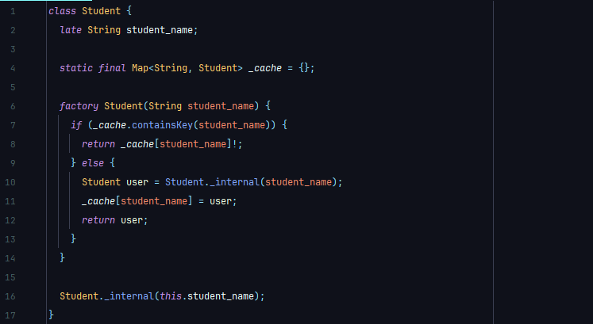
Example 2:
In the above example we create a Class name Student then create an Attribute name student_name the create a Map name _cache that contains the Instance/Object we create by the Student Class.
Then we create a Factory Constructors that check the condition that if the Object we create now is created in the previous then just return the same Object. Otherwise create a new Object then return it.
Remember that Factory Constructors doesn’t create an Object it checks some condition then return the named constructors.
Key Differences Between Factory and Const/Normal Constructors
Feature | Factory Constructor | Const / Normal Constructor
Returns new object | Not always | Always
Logic allowed | Yes | No logic
Subclass return | Yes | No
2.2.6. Redirecting Constructors
A Redirecting Constructor is a constructor that calls another constructor in the same class to reuse initialization logic. Instead of repeating code, you can redirect one constructor to another using ( : ) syntax.
Example 1:
class Student {
String student_name;
int student_age;
Student (this.student_name, this.student_age) {
Para. Constructor with direct initializer
Print ('Student name: $name. Student age: $age.');
}
Student.guest (String name, int age) : this (name, age);
Redirect Constructor with Parameters
}

Notes Table
Redirecting constructors cannot have a function body.
You can redirect to any constructor in the same class (even a named one).
You can’t redirect to a factory constructor.

2.3. Class Inheritance
Inheritance is a key concept in Object-Oriented Programming (OOP). It allows one class (called the child or subclass) to inherit the properties and methods of another class (called the parent or superclass). Dart supports only single inheritance – a class can inherit from one superclass.

Example 1:
class Parent { Parent Class Contain Method sayHello ()
void sayHello () {
print ("Hello from Parent");
}
}
class Child extends Parent { Child Class Inherited Parent Class All Data
void sayHi () {
print ("Hi from Child");
}
}

Child c = Child (); Create Child Class Object Name c
c.sayHello (); Call Parent Class Method by Child Class Object
c.sayHi (); Call Child Class Method by the Same Object

In Class Inheritance, we always create Child Class Object. Then by the Object we call the Parent Class Method or Attribute.

2.3.1. Parent Class Constructor Inheritance By Super Keyword
In Dart, we can inherit Parent Class Constructor by super Keyword. The Syntax look like:
Child_Class_Constructor () : super ();
We can do this by using (:) Operator and super (). It will call the parent class constructor and all the attribute or method that constructor contains.
Like wise we can Inherit Parent Class Method by Super Keyword. The Syntax look like:
super.Parent_Class_Method_Name ();
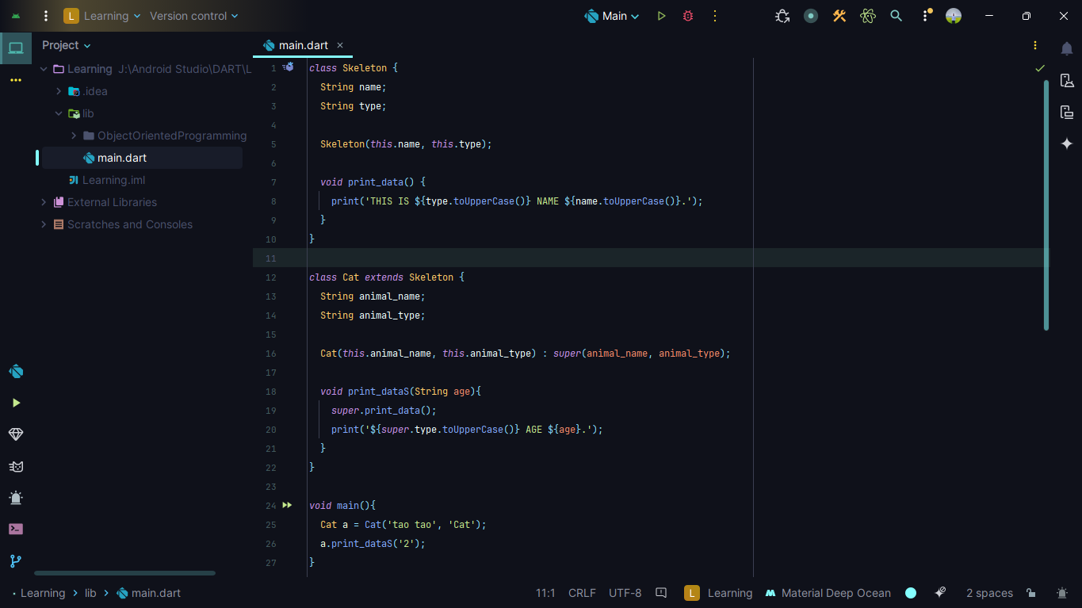
Example 1:
Here, we use Class Inheritance, Constructor Inheritance also Method and Attribute Inheritance using the super Keyword and so. . . on,

2.4. This, Static and Method Overriding In Dart
We will see this, static, Method Overriding one by one. To learn those, you must complete the section we complete.

2.4.1. Method Overriding
Method Overriding is same in every language. But, in dart we have some difference. Let’s see one by one:
In Dart, you override a method when you want to provide a specific implementation for a method that already exists in the parent class.

Example 1:
class Parent {
void greet () {
print ("Hello from Parent");
}
}
class Child extends Parent {
@override
void greet () {
print ("Hello from Child");
}
}
In Dart, you can override method by using the @override Syntax. In overriding, you must right the same name and the parameter in the Child Class.

Rules of Overriding in Dart
Rule | Description
Must use same method name | Including same parameters
Can change method body | But not return type (unless it's a subtype)
Use @override | For clarity and safety
Can call super.method() | To include parent logic

2.4.2. This Keyword In Dart
The this keyword in Dart is a reference to the current instance of a class. It’s used inside a class. For:
- Access instance variables and methods
- Differentiate between class fields and constructor parameters
- Pass the current instance as a parameter

2.4.3. Static Keyword In Dart
In Dart, the static keyword is used to declare class-level variables or methods — meaning they belong to the class, not to any specific object.
That means when we create a static variable or method we say it belong to the Class not the Object. Here, the Object means the Class Object.
What Does static Do:
- You can access static members without creating an instance of the class.
- Useful for utility methods, shared data, or constants.
We can access the static variable or method by right - ClassName.static_variable_name
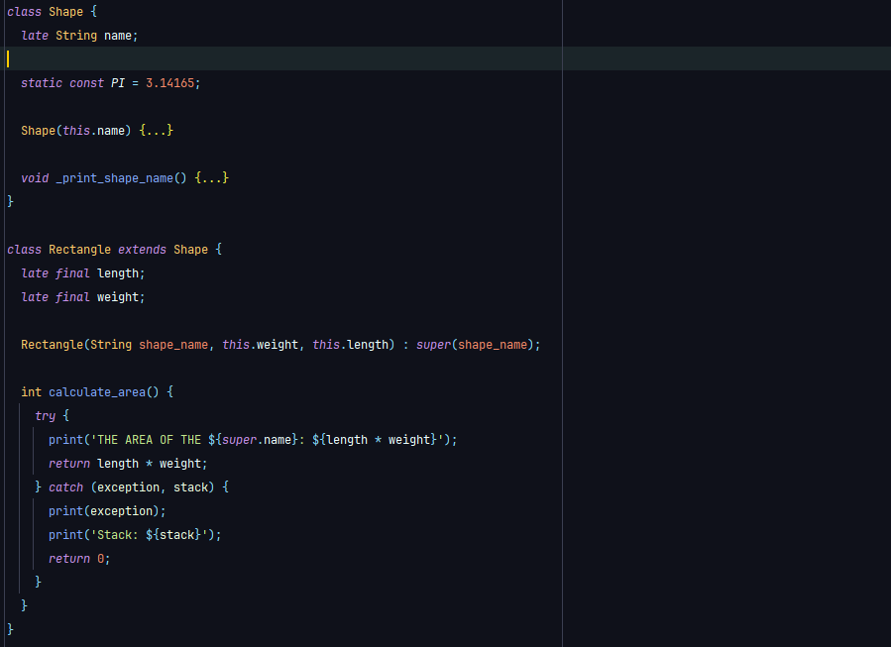
Example 1:
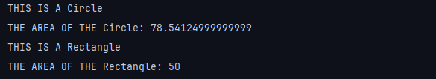
The Output:

Here, in this example we use the static variable name PI. We access the variable by right the Class name (.) Variable name. Ex:
Shape.PI

2.5 Abstract Classes & Interfaces
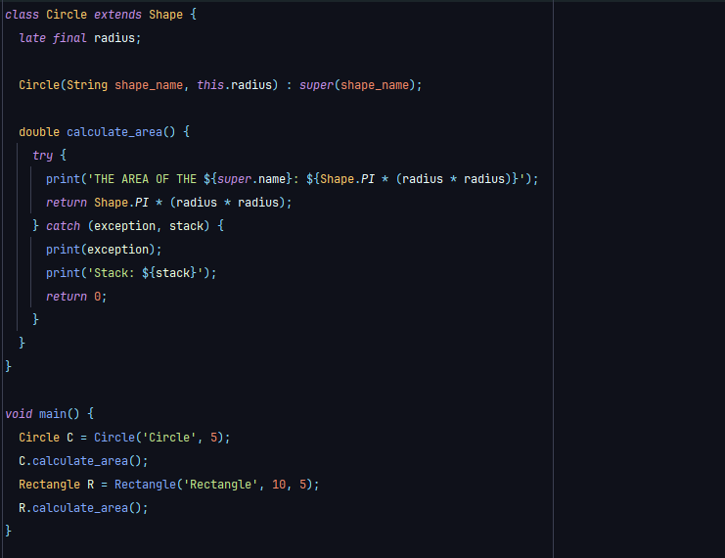
Dart supports object-oriented programming, and like other OOP languages, it provides abstract classes and interfaces for creating flexible and reusable code structures. While Dart doesn’t have a separate interface keyword. Every class in Dart can act as an interface.

Abstract Classes
- Is a class that cannot be instantiated directly.
- Can have abstract methods (methods without implementation).
- Can have implemented methods, fields, and constructors
- Is designed to be inherited by subclasses.

Example 1:
abstract class Animal {
void make_sound ();
Abstract Method That Don’t Contains Method Body.
void breathe () { Normal Method That Contains Method Body.
print ("Breathing...");
}
}
In Dart Programming, we can create both Abstract Method or Normal Method. But, some other Programming Language we can’t create a Normal Method in Abstract Class. Now, as we see we can’t create an Object From Abstract Class. So, we must extend it by other Sub Class then we can create an Object and access the method and attribute.
When we extend the Abstract Class we must assign value to the Abstract Attribute or Method.
Example 2:
abstract class Animal {
void make_sound ();
Abstract Method That Don’t Contains Method Body.
void breathe () {
Normal Method That Contains Method Body.
print ("Breathing...");
}
}
class Dog extends Animal { Extends Abstract Class Name Animal.
@override
void makeSound () {
Override The Abstract Method & Assign Method Body.
print("Bark");
}
}
Now, we can use Factory Constructor in Abstract Class too. But there is some Problem That We Can Not Create an Instantiated in Factory Constructor.
Here, An Instantiated means. . .
ClassName._initials ();
We cannot right it in the Factory Constructor. Because, Abstract Class Doesn’t Support Instantiated.
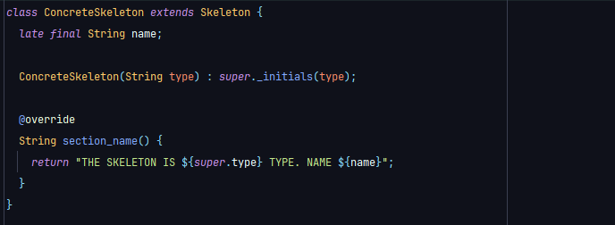
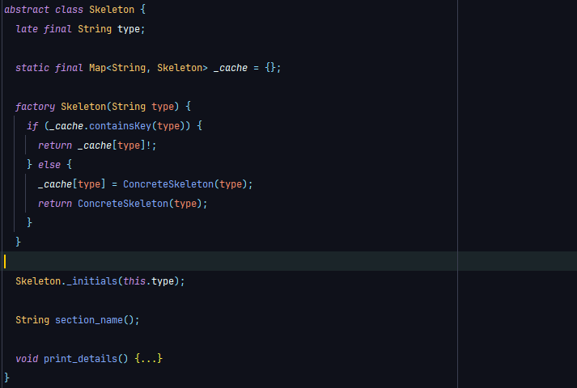
So, we must create another class then Extends the Abstract Class then Return the Extends Class Name.

Interface In Dart
In Dart, every class is an interface. You can use any class as an interface by using the implements keyword.
When you implement a class, you must override all its methods and fields, even if they have implementations.

Example 1:
class Vehicle {
void start () {
print ("Starting engine...");
}
}

class Car implements Vehicle {
@override
void start () {
print ("Car started");
}
}
Unlike extends, implements don’t inherit implementation, only the structure (method signatures). When you create a Class with Argument Constructor. IF you implement the Class then the Constructor will be no use it will auto disable.
Scenario | Use
You want to define base functionality | Abstract Class (extends)
You want to enforce a structure only | Interface (implements)
You need to share implementation and logic | Abstract class (extends)

2.6 Mixins in Dart
A Mixin in Dart, is a way to reuse code across multiple classes without using traditional inheritance. They allow you to add functionality to classes in a flexible, composable way.
- To share methods and properties across different classes
- Avoid limitations of single inheritance
- Provide reusable behaviors without needing a class hierarchy
Rules For Mixins
- Use the mixin Keyword
- Mixins cannot be instantiated (Like the Abstract Class)
- A class can use multiple mixins
- Mixins can extend or apply constraints using on Keyword
Syntax:
mixin MixinName {
Methods and Attributes.
}
class ClassName with MixinName {
Can Access Methods and Attributes.
}
Example 1:
mixin Logger {
void log (String message) {
print ("LOG: $message");
}
}
class FileManager with Logger {
void saveFile () {
log ("File saved");
}
}
You can use multiple mixins by (,) sign,
Example 2:
mixin A {
void a () => print('A');
}
mixin B {
void b () => print('B');
}
class C with A, B {}
By that we can use A & B mixin methods and attribute.
Now Mixins with Constraints, means we can use extends & mixin at a same time. To do that we first use mixin then extends.
Example 3:
class Animal {
void eat () => print ("Animal eats");
}
mixin CanRun on Animal {
void run () => print ("Running...");
}
class Dog extends Animal with CanRun {}

2.7 Getters and Setters
In Dart, getters and setters are special methods that let you read and write private or protected fields of a class in a safe and controlled way. They allow encapsulation, which is a key principle in object-oriented programming.
A Getter is used to retrieve a value from a private field & A Setter is used to update or change a value of a private field.
Benefit | Description
Encapsulation | Control access to internal fields
Validation logic | Add checks in setters before assigning values

Example 1:
class Person {
String _name = ''; Private Attribute or Variable.
String get name => _name; Get the Private Variable Value.
set name (String value) { Set the Private Variable with Condition.
if (value.isNotEmpty) {
_name = value;
} else {
Print ("Name cannot be empty");
}
}
}
void main () {
Person SanjidDad = Person ();
SanjidDad.name = ‘Sanjid Dad’;
print (SanjidDad.name);
}
In Dart Programming Language, we can use Condition in the Setters that make our Setter stronger & more Controlled. Here, the setter and getter must be the same name. Here, in the example we use name. Setter must take one or more parameters as an input and assign to the Private Variable. Then, Getter return the Private Variable that we can Print.
In the main Function, we use [SanjidDad.name = ‘Sanjid Dad’;] this to set the name in the private variable.
Behind the scene, Dart called the [set name (String value)] Method & set in the Private Variable. Then, we Print the Getters by Print the same thing [print (SanjidDad.name);]

Advanced Dart Programming

3.1. Asynchronous Programming
Asynchronous programming in Dart allows your app to perform time-consuming tasks (File I/O, API Calls, or Timers) without freezing the program. It is needed because: To avoid blocking operations,
1. Network requests 2. File Read/Write 3. Database Access
4. Delays
In Asynchronous Programming we use the concepts:
Concept | Keyword/Type | Purpose
Future | Future<T> | Represents a value that will be available in the future.
async | async | Marks a function that has await calls means Function is waiting for result.
await | await | Waits for the future to complete
then | .then() | Handles future results (chaining)

3.1.1. Future In Dart
A Future in Dart, represents a potential value or error that will be available at some point in the future usually the result of an asynchronous operation like reading a file, making an HTTP request, or querying a database.
Think of a Future like a promise to return a value later, not immediately.
Syntax:
Future<String> method_name () {
Code Operations return or print data.
}
States Of a Future:
- Uncompleted – Waiting for the result.
- Completed with data – Successfully returned a value.
- Completed with error – Failed with an exception.
Example 1:
Future<String> print_data () {
return Future.delayed (
Duration (seconds: 2),
() => 'Data Loaded',
);
}
Here, in this example this Future will complete after 2 seconds. Until then, it's Incomplete. IF came with value then Complete with data otherwise Complete with error.
Here, the program returns the String ‘Data Loaded’.

3.1.2. Async In Dart
In Dart Programming, the async keyword used to mark a function as asynchronous.
Meaning, it returns a Future (implicitly). You can use await inside it to pause execution until the awaited future completes.
We use async, to write non-blocking code that waits for time-consuming operations. Like:
- Network requests.
- File I/O.
- Timers.
- Database calls.
Without Freezing the App or Function Flow.

Syntax:
Future<String> method_name () async {
Code Operations return or print data.
}
This is same as Future. You just put async in the middle between the () and the {}.

Example 1:
Future<String> print_data () async {
return Future.delayed (
Duration (seconds: 2),
() => 'Data Loaded After 2 Second',
);
}
void main () async {
print(‘Start’);
String data = print_data ();
print (data);
print (‘End’);
}
Here, in this example print Start then after 2 second print Data Loaded after 2 second then print End. IF we call the Function that use Future and async then we must use async in the main Function to because it only prints when it Find async.

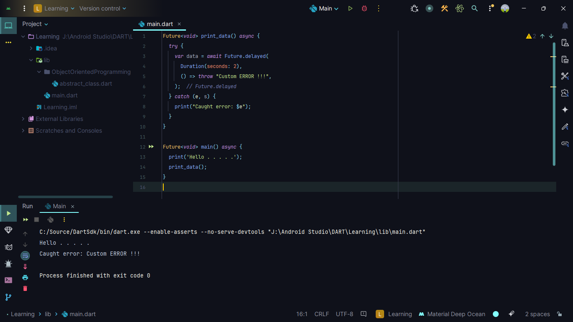
Example 2:

Like this we can use main Function as a Future<void> to print the Future Function name print_data
3.1.3. Await In Dart
The await keyword in Dart is used inside an async function to pause execution until a Future completes. It waits for an asynchronous operation to finish before continuing the next line of code.

Example 1:
Future<String> print_data () async {
await Future.delayed (Duration (seconds: 2));
return 'Data Loaded After 2 Second';
}
Future<void> main () async {
print(‘Start’);
String data = await print_data ();
print (data);
}

3.2 Generics (List<T>, Map<K, V>) In Dart
Generics in Dart allow you to write flexible, reusable, and type-safe code. Instead of specifying a data type directly, you use type parameters like T, K, and V.

3.2.1. What Are Generics
Generics let you write code that works with any data type, while still maintaining type safety at compile time. Some Common Generic Types in Dart:
- List<T> (A List Of Elements Of Type T).
- Map<K, V> (A Map With Keys Of Type K & Values Of Type V).

Example 1:
List<int> numbers = [1, 2, 3];
List<String> names = ['Alice', 'Bob'];
Here, the we use List<T>. T means the type that the list contains.
Map<String, int> scores = {
'Math': 95,
'Science': 90,
};
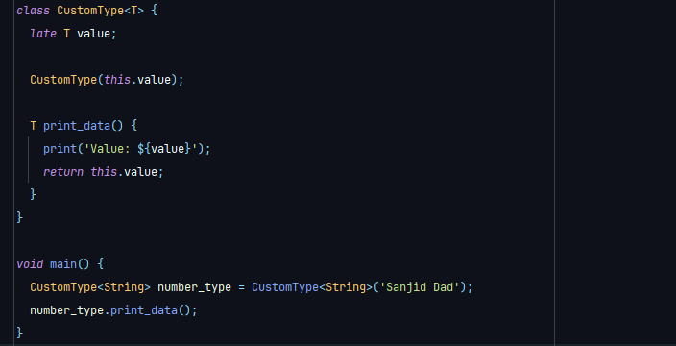
Here, the we use Map<K, V>. K means the map key & the V means the type that the map contains. Now, we can create our own generics type. Here, an example,
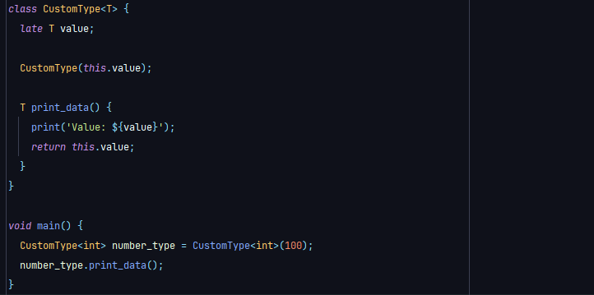
Again, using the int data-type,

Why Use Generics,
Benefit | Description
Type safety | Catch errors at compile time
Reusability | Write code once, use with any type
Better performance | Avoids runtime type checks
Cleaner code | Avoids casting

3.3. Extensions In Dart
Extensions in Dart allow you to add new functionality to existing classes - even if you didn’t write or own those classes - without modifying the original source code.
An extension lets you define additional methods, getters, or setters for a class outside of the class itself. This is especially useful for some data-type operations. Like: String, int, double, Etc.

Syntax:
extension user_define_name on data-type/class {
Your Own Code Like Logic or Syntax.
}

Example 1:
extension number_extension on int {
bool isEven () => this % 2 == 0;
bool squared () => this * this;
}
void main () {
int number = 100;
print (number.isEven); Print True or False by the Number.
print (number.squared()); Print the Squared Number.
}
Here, In this example we create an Extension For int name squared () it squared the numbers then return the numbers. It is useful when you to check some conditions to the variable Before you use it in the Operations.

Example 2:
extension email_validator on String {
bool isValidEmail () => contains ('@') && contains ('.');
}
void main () {
String email = "test@example.com";
print (email.isValidEmail()); Print True or False by the Number.
}
Here, Is a good example that, Spouse you take input the user. Then you check the input is it valid or not. IF the input is valid then use it on the Operation. Otherwise show user Error.

3.4 Typedefs In Dart
In Dart, typedef is used to create a custom name For a Function Type. A typedef (Short For Type Definition) allows you to name a Function type and then use that name to declare variables, parameters, or Fields that accept Functions of that type.
There are two Syntax in Typedefs. First one is only use by creating the Function name with or without Parameter & the second one is creating a variable by use the return type then Function name with or without Parameters.
Syntax:
Typedef Function_name (Parameters); First Syntax Options.
Typedef variable_name = return_type Function_name (Parameters);
Second Syntax Options.

In Dart, we can create a Function model then create as many as Function we want use by the Function model. Then, what we do just create a main variable the Typedefs & call the Function by the variable.
This is a core concept in Functional Programming: Passing Functions as values.
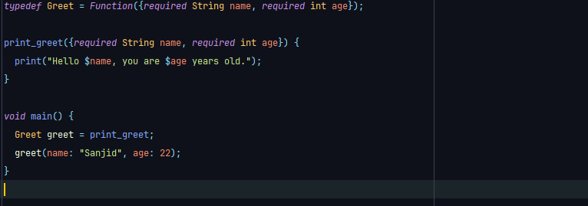
Example 1:
Here, we create a Typedefs Function then create a Function name print_greet that contains same Parameters in the Typedefs Functions.
Then, we create a variable name greet in the main Function by the type Greet (What We Create in the Typedefs) then assign the value as a Function we create earlier name print_greet.
Then, pass the Parameters to call the Function.
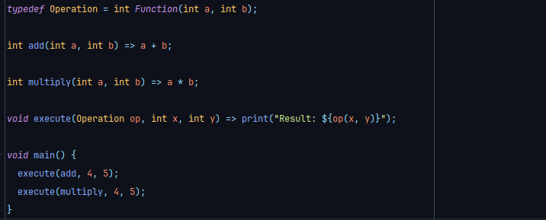
Example 2:
Here, you created a template (typedef) to use math operations, and then reused it to pass different Functions (add, multiply) as arguments into another Function (execute).

Why Use Typedefs,
Concept | Descriptions
Typedefs | Creates a name for a function signature
Cleaner code | Helps reduce repetition in complex signatures
Use cases | Callbacks, Flutter widgets, Functional programming

3.5 Enums (Including Enhanced Enums) In Dart
In Programming Languages, we use constant. Every Programming Language use different type Syntax Constant. In Dart Programming, we use Enums (short for enumeration) it is a special type in Dart used to define a fixed set of constant values.
Syntax:
Enum variable_name {
- Constant Fields.
}
To access the element and work with it we use Enums as a Class & Object. First create an Enums then create a variable to the main Function to access the Enums.

Example 1:
enum Colorname { Create an Enum name Colorname
red,
green,
white,
}
Void main () {
Colorname select_color = Colorname.red;
Create a variable For Enum & Assign value.
Print (select_color); Print the variable select_color.
Print (select_color.name);
Print the Name Of the Enum Constant By Variable.
}

Now, How we work with Enums,
enum Colorname { Create an Enum name Colorname
red,
green,
white,
}
Void describe_color (Colorname color) {
switch (color) {
case Colorname.red:
print ("Red color");
break;
case Colorname.green:
print ("Green color");
break;
case Colorname.white:
print ("White color");
break;
case Colorname.orange:
print ("Orange color");
break;
}
}
Here, we use switch case, For each Enum Constant we create each Block Code that print some data. Remember that when we create an Enum we must declare and assign value to all. IF we miss one then the code will give us Error.

Why Use Enums:
- Improves code readability.
- Prevents use of magic strings or numbers.
- Enforces type safety.
- Used in state management, switch cases, options, etc.

3.5.1. Enhanced Enums
Enhanced Enums take traditional Enums to the next level. They allow you to define Fields, Constructors, Methods, and Even Implement Interfaces or Mixins — making Enums powerful and expressive.
An enhanced enum is just like a class:
1. You can define Fields. 2. Add a Constructor 3. Define Methods
4. Implement Interfaces 5. Use switch, name, index, and more.
In Dart Programming, Enhanced Enums is more like Class. Like the Class we can create Constructor, Method, Fields also we can Implement Interfaces and we can use switch, name, index or more in Operations.
In Class we must create an Object to work with it. But, in Enums we do not create any Object. We call directly by the name or index.
Example 1:
Enum Vehicle {
Car (max_speed: 120),
Classic Enums What we Create In the Past.
Bike (max_speed: 80),
Classic Enums What we Create In the Past.
Truck (max_speed: 60);
Classic Enums What we Create In the Past.

final int max_speed;
Create New Filed Name max_speed.

const Vehicle ({required this.max_speed});
Create Constructor Like Classes.

void describe () { Create Method Name describe.
print ('The $name can go up to $max_speed km/h');
}
}
In this example, we see we can create all the thing we can create in Dart Classes.
Void main () {
Vehicle.Car.describe (); Call the describe Function.
Print (Vehicle.Bick.max_speed); Print the max_speed Variable.
}
Here, In Dart Programming we must create an Object to use the Class. Enums are same as Class. But, we do not need any Object to use the Enums Value. Because, In this Enums we create 3 Constructors not only Constructors it is named Constructors.
So, we can say that we can use Enums by the Constructors.
By Saying --- Enums_name.Constructors_name.Method_name
We use (.) Operators to access the Variable or Method in the Enums same as Classes & Objects.
Rules For Enhanced Enums:
- Must declare const Constructors.
- Fields must be Final.

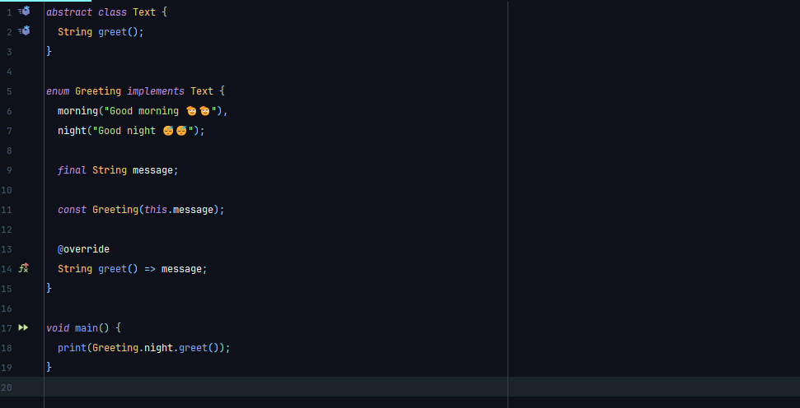
Example 2:

Here, we create Abstract Class name Text. Then Implement the Text Class in the Enums. So, we can Implement in Enums we cannot Extend Enums.

Enums & Enhanced Enums Summary:
Feature | Basic Enum | Enhanced Enum
Fixed values | Yes | Yes
Fields & methods | No | Yes
Constructors | No | Yes
Implements | No | Yes

3.6 Cascading Notation In Dart
The Cascade Notation (..) in Dart allows you to perform multiple operations on the same object without repeating its name. It improves code readability and conciseness, especially when configuring objects with many properties or methods.

Syntax:
Object_name.Property = Value; Access & Assign with . Notations.
..Property = Value; Assign Value With .. Cascading Notation.

Why Use Cascade Notation
Without Cascade | With Cascade
person.name = "Alice"; | person..name = "Alice"
person.age = 30; | ..age = 30
person.greet (); | ..greet ();

Example 1:
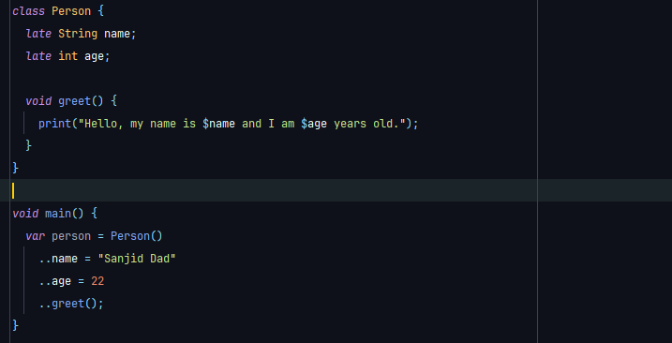
Here, we create a Class name Person then create two Variables. One name & one age. Then create a method name greet.
Now in the main Function we create an Object name Person then we use Cascading notation (..) to assign the value in name & age variable. Then same as we call the method by using the Cascading notation.
Here, one thing to remembers we do not give any semicolon (;) to any syntax.
Example 2:
List<String> names = []
..add("Alice")
..add("Bob")
..add("Charlie");
We can also use the Cascading Notation in Method Chaining.
Dot | Meaning
. | Call or access directly
.. | Call and return the object again

3.7 Tear - Off Syntax In dart
The Tear-Off Syntax in Dart allows you to Pass Functions or refer to Methods or Constructors without calling them. It’s like taking a Function or Method and "Tearing it Off" from its Object or Class to use it as a First-Class Function.

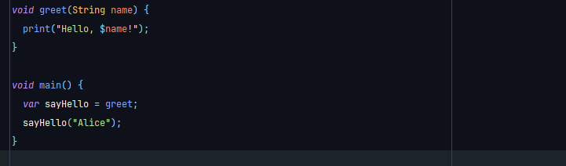
Syntax:

Here, in this example we First Create a Method then in the main Function we First Create a Variable name sayHello. In that Variable we assign the Function name not the Function Fully.
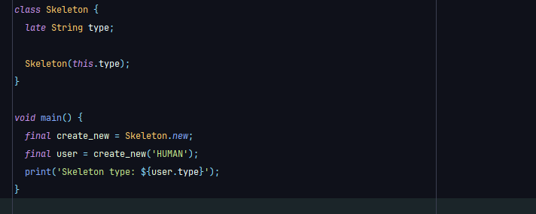
In Class & Constructors Example:

Here, in this example we create a class name Skeleton the create a variable name type & a constructor. So, this class take a parameter name type. Now, In the main Function we First create a variable For Class reference by saying Class_name.new (Tear Off) without calling it.
Then we use the variable & call the constructor. It behaves exactly like calling Skeleton("HUMAN"). A new Skeleton object is created with type HUMAN.
We can also Tear-Off - Method, Static Variable, and more.
3.8 Null-Awareness Operators & Spread Operators In Dart
We already reach the end our Advance Dart learning Section. There are one more listen to go. Now, In this section we learn Null-Awareness Operations.
There are 4 type Null-Awareness Operators:
Null-Aware Operators | Name
?? | IF - Null
?. | Null-Aware Access
??= | IF - Null Assignment
! | Null Assertion

3.8.1.1 IF – Null Operators (??)
Here, it returns the Right-Hand Side IF the Left-Hand Side is Null.
Example 1:
void main () {
String? name; Create a Variable that is Null with Null – Operators.
name = name ?? 'Sanjid Dad';
It Return the Right-Side Value IF the Variable is Null.
print (name);
}
Here, name ?? 'Sanjid Dad' return Sanjid Dad. Because the name is Empty.

3.8.1.2. Null-Aware Access Operators (?.)
Here, It Calls a Method or Accesses a property only IF the Object is Not Null.
Example 1:
void main () {
String? name; Create a Variable that is Null with Null – Operators.
print (name?.length); Here It Print Null (Instead Of Throwing an Error)
}
Here name?.length print Null. Because the name is Empty & it not Throwing an Error.

3.8.1.3. IF - Null Assignment Operators (??=)
Here, It Assigns a value only IF the Variable is Null.
Example 1:
void main () {
String? name; Create a Variable that is Null with Null – Operators.
name ??= 'Sanjid Dad';
It Assign the Right-Side Value IF the Variable is Null.
print (name);
}
Here name ??= ‘Sanjid Dad’ assign Sanjid Dad in the name Variable. Because the name is Empty.

3.8.1.4. Null Assertion Operators (!)
This Operators is Special. Because, it Forced Dart Programming Language to Commit that the Variable is Null. It doesn’t matter IF the variable is not Null.
Example 1:
void main () {
String? name = 'Sanjid Dad';
We Create a Null Variable. But, we assign the value.
Print (name!); This Operators it Check Is the Variable Null.
}
Here, (!) Operators check IF the Variable is Non-Null or Not. IF the Variable is not null then work as it is. But, IF the Variable is Null then it Print Errors.

3.8.2. Spread Operator in Dart (..., ...?)
In Dart Programming, Spread is use to insert variable to another variable. Most case’s it is use in List’s. Also, we can do it manually by using the List Methods.
Here, we use 2 type Spread:
- . . . (Spread).
- . . . ? (Null Aware Spread).
Example 1:
List<int> numbers_list = [1, 2, 3];
List<int> numbers_list_two = [0, . . . numbers_list, 4];
Use Spread to add the numbers_list List.
Here, in the number_list_two the List will be [0, 1, 2, 3, 4]. This is most use in the Application Development.

Example 2:
List<int>? numbers_list;
List<int> numbers_list_two = [0, . . .? numbers_list, 4];
Use Spread to add the numbers_list List.
Same, as Example 1. Here, in the number_list_two the List will be [0, 4]. It doesn’t give us Error because we add Null Check Operators. This is most use in the Application Development.

Dart Functional Programming

4.1 Anonymous Functions / Lambdas In Dart
An anonymous Function (also called a Lambda or inline Function) is a Function without a name.
You usually use them when you need a Short, Temporary Function, often as a callback or inside Higher-Order Functions like forEach, map, or where.
It is same what we learn in our 1st Function chapters. Also, the Higher-Order Function.

4.2 Higher-Order Functions In Dart
A Higher-Order Function is a Function that does at least one of the following:
- Takes another Function as a parameter.
- Returns a Function as its result.
In Dart (and many modern languages), Functions are First-Class Objects, meaning you can:
- Store them in variables.
- Pass them as arguments.
- Return them From other Functions.

4.2.1. Takes Another Function as a Parameter in Dart
Dart allow you to pass Functions as a Function Parameters. It allows you to access more control or strength in the Function.
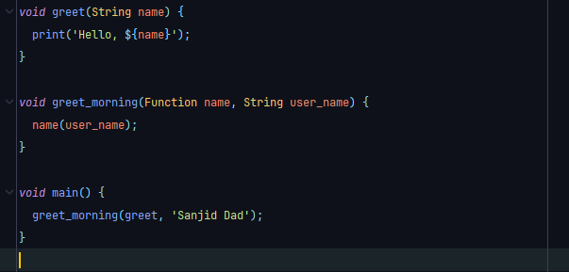
Example 1:
Here, in the example we First create a Function name greet that take a parameter called name. Then, we create a Function greet_morning that take two parameters, one name Function type then user_name String type.
In the main Function we call the greet_morning Function then pass two parameters one is greet Function & Second is String.
In the output in rint Hello, Sanjid Dad.
4.2.2. Returns a Function as its Result in Dart
Dart allow you to return a Function in the Function. Means we can create a Function that can return another Function.
Many times, in Real Life example we use that to return a Function instead returning a Single or Multiple Values.

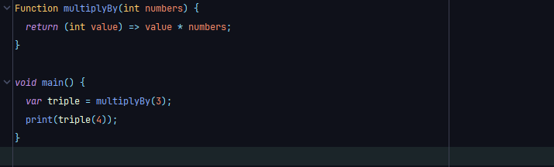
Example 1:

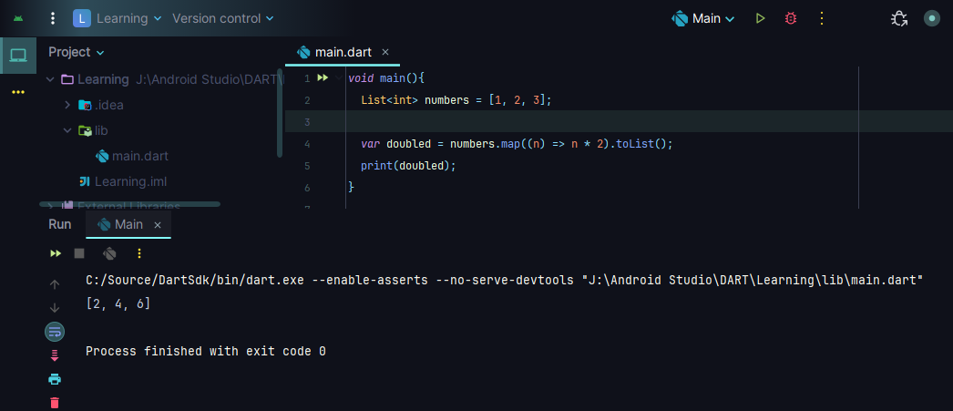
Here, is a Real-Life Example:

In Dart Programming map, forEach, where are the Higher-Order Function we use in Real-Life.
4.3 Closures In Dart
A Closure in Dart is a Function that "remembers" the variables From the Scope in which it was created, even after that Scope Has Finished Executing.
Closures capture variables From their surrounding environment and Hold on to them.
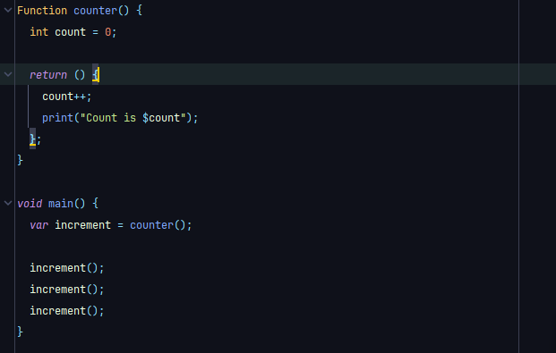
Example 1:
Here, in this example we create counter Function that returns an Anonymous Function (a Closure). That Function remembers the value Count even after Counter Has Finished. Every time we call increment (), it still Has access to count.
Property | Description
Captures variables | Remembers variables from the outer scope.
Keeps state | Can Keep and Change data even after outer Function ends.
Used For Callbacks | Very useful For event Handling, data processing, etc.

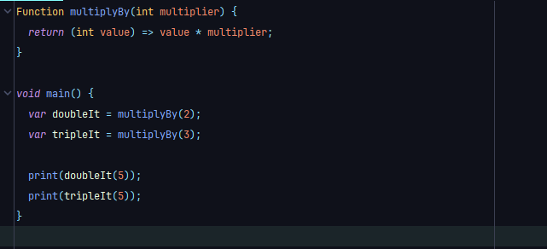
Example 2:
Here, Each Closure remembers its own multiplier value.
4.4 Collection Methods In Dart Programming
To Finish this chapter or the Advance Dart Programming we must know all the Collection Methods. Because, in our Real-Life we use it a lot.
Here, we already learn all the Collections (List, Set, Map).

4.4.1. List<T> Methods In Dart
Here, all the Methods in List<T>:
- add (element) Adds a single element to the list
- addAll (iterable) Adds multiple elements
- insert (index, value) Inserts element at a given index
- insertAll (index, iterable) Inserts multiple elements at index
- remove (value) Removes the first occurrence of value
- removeAt (index) Removes element at index
- removeLast () Removes the last element
- removeWhere (test) Removes elements that satisfy a condition
- retainWhere (test) Keeps only elements that satisfy a condition
- clear () Removes all elements
- contains (element) Returns true if list contains the element
- indexOf (element) Returns the index of the first match
- lastIndexOf (element) Returns last index of the element
- elementAt (index) Returns the element at a specific index
- forEach (action) Loops through each item
- map (f) Transforms each item and returns a new Iterable
- where (test) Filters the list based on a condition
- reduce (callback) Reduces list to single value (requires non-empty)
- fold (initial, callback) Accumulates values starting from initial
- any (test) Returns true if any item satisfies condition
- every (test) Returns true if all items satisfy condition
- expand (f) Expands each element to multiple elements
- join ([separator]) Joins list into a single string
- sort ([compare]) Sorts the list (in-place)
- reversed Returns a reversed iterable
- sublist (start, [end]) Returns part of the list
- asMap () Converts list to map with index as key
- shuffle () Randomly shuffles elements
- fillRange (start, end, [fill]) Fills range with value
- replaceRange (start, end, iterable) Replaces range with new elements
4.4.2. Set<T> Methods In Dart
Here, all the Methods in Set<T>:
- add (value) Adds value if not present
- addAll (values) Adds all values
- remove (value) Removes value
- removeWhere (test) Removes all elements satisfying condition
- retainWhere (test) Keeps only elements satisfying condition
- contains (value) Checks if value is in the set
- clear () Removes all elements
- union (otherSet) Returns union of two sets
- intersection (otherSet) Returns common elements
- difference (otherSet) Returns items not in otherSet
- forEach (action) Iterates over each element
- lookup (value) Returns matching element if present

4.4.3. Map<K, V> Methods In Dart
Here, all the Methods in Map<K, V>:
- addAll (other) Adds all key-value pairs from another map
- remove (key) Removes a key and its value
- removeWhere (test) Removes entries that match the test
- clear () Removes all entries
- containsKey (key) Checks if a key exists
- containsValue (value) Checks if a value exists
- forEach (action) Loops through each key-value pair
- putIfAbsent (key, ifAbsent) Adds key if absent
- update (key, updateFn) Updates value if key exists
- updateAll (updateFn) Updates all values
- keys Returns iterable of all keys
- values Returns iterable of all values
- entries Returns iterable of MapEntry objects
- map ((key, value) => ...) Transforms the map

Dart Package & Library Management

5.1 What is Package & Library Management in Dart
Dart Has a Robust System For managing Packages and Libraries, allowing you to use External Code or Organize your own code Efficiently.
This is especially essential when working on larger Dart or Flutter Projects.
In the Package & Library Management we mainly use some sections. Like:
- Using pubspec. yaml (The Package Configuration File)
- Importing Libraries. (Use import Keyword)
- Creating and Publishing your own Packages.

5.2 Package Configuration In Dart
Package Configuration in Dart refers to How Dart projects manage and locate external packages, dependencies, and libraries — controlled through a Central File and related tools.
In Dart we use a pubspec. yaml Central Configuration File For any Dart & Flutter Projects. It defines the project metadata, dependencies, SDK constraints, assets, and more.

5.2.1. Creating pubspec.yaml File
To create the pubspec. yaml Central Configuration File. We First create a Project with a name. Then create a bin Folder For the main File & the pubspec. yaml File. Ex:
My-Project/
|------- pubspec.yaml
|------- bin/
|------- main.dart
In the pubspec.yaml we right some Fields (name, description, version, environment, dependencies, dev_dependencies) that contain Projects metadata.

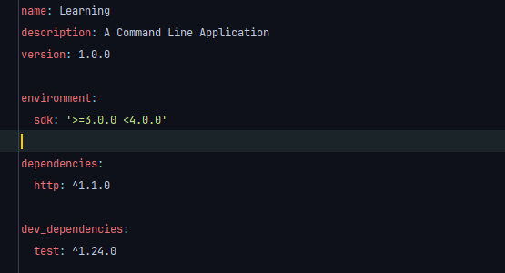
Here, every Filed contains some specific data.
Field | Description
name | Name of your project/package
description | A Brief description
version | Version number (semver: major.minor.patch)
environment | Specifies Compatible Dart SDK Versions
dependencies | Packages needed for runtime (Editable)
dev_dependencies | Packages needed only development (Editable)
Here, In the dependencies and the dev_ dependencies section we can add as many we want in our projects. For example, we use Http Package.
We can Find all dependencies in the pub.dev (The Official Website For Dart Packages).

5.2.2. Adding Dependencies in pubspec.yaml File
For adding the dependencies in the center configuration File we use pub.dev website. Here, in the same project what we create in previous example we adding a package name intl. This package is used For internationalization.
It Helps you Handle date/time formatting, number formatting, currencies, pluralization, and messages based on locale. At First,
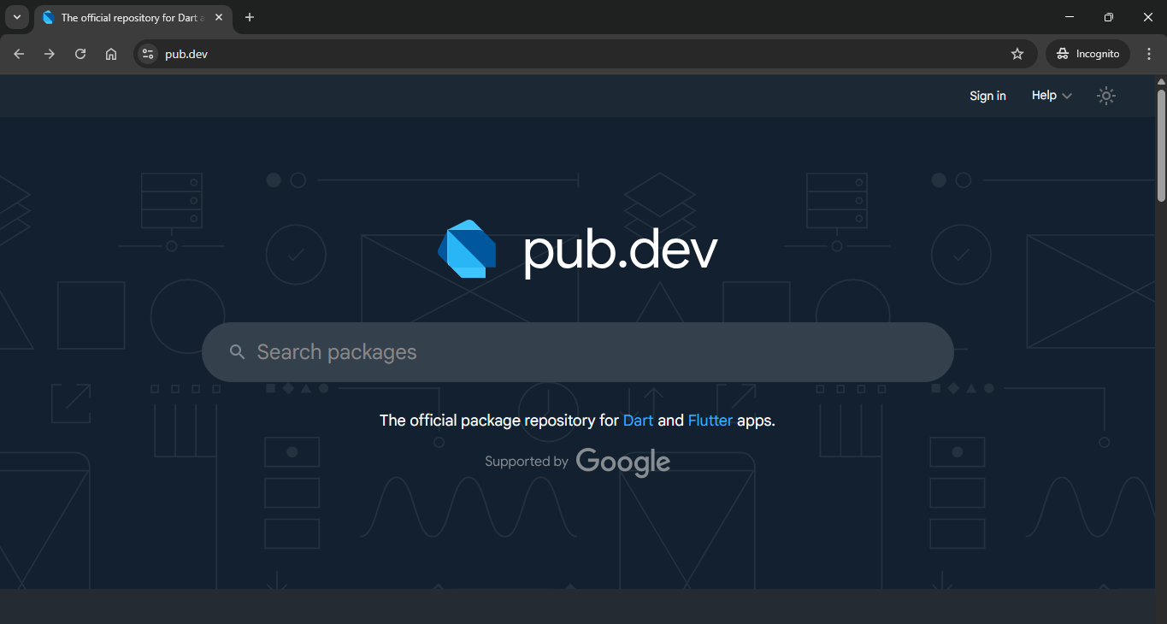
Go to the pub.dev Website then search For intl package,
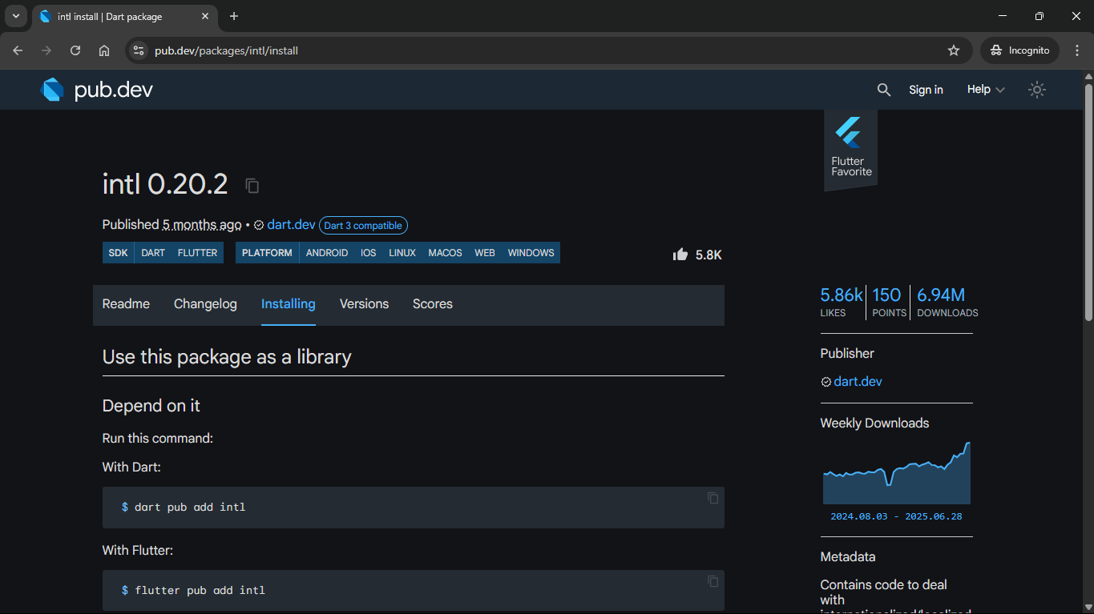
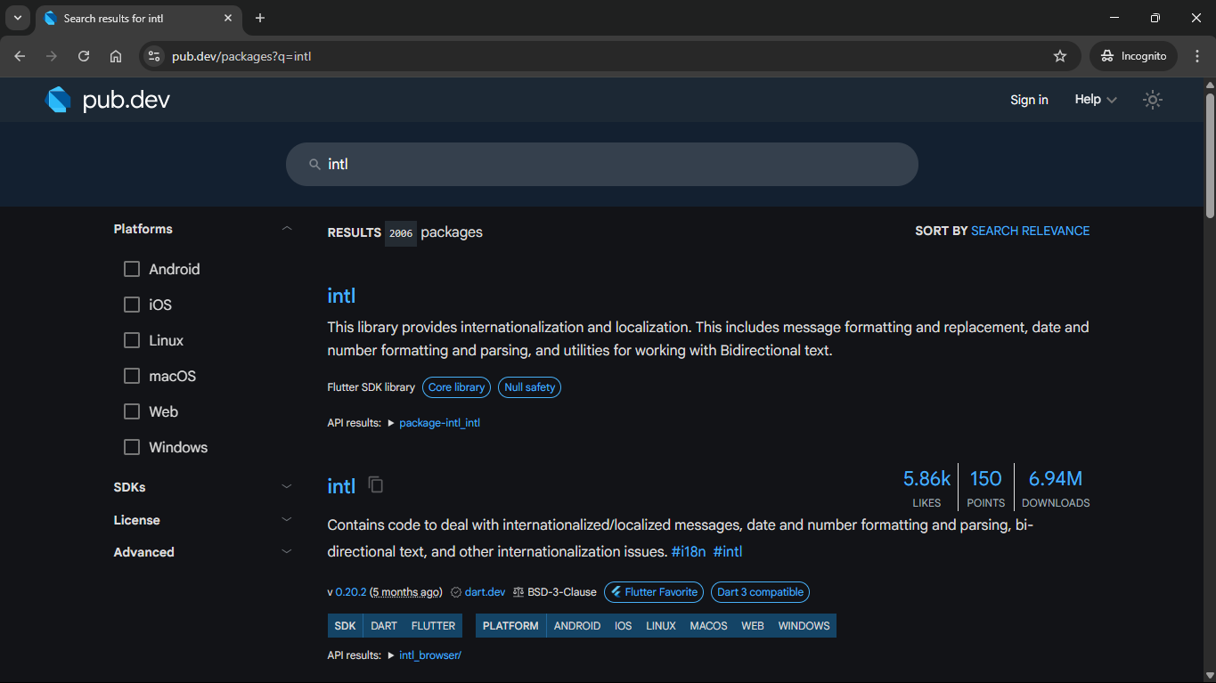
Now, we can see there is a package name intl with a Likes | Points | Downloads. Now then, go to the package and go to the Installing tab.
We can see, there is a Command with Dart,
$ dart pub add intl The Command For Download the intl Package.
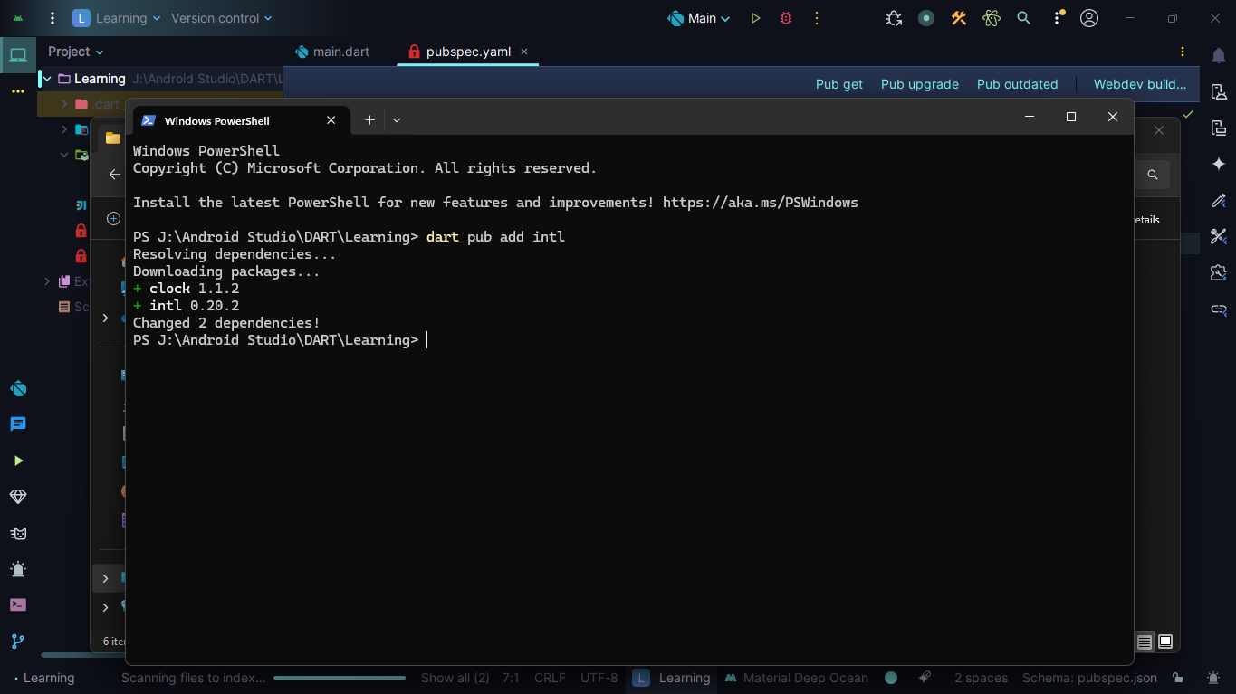
Copy the command and go to your project root Folder and open a terminal then paste the command and Enter.
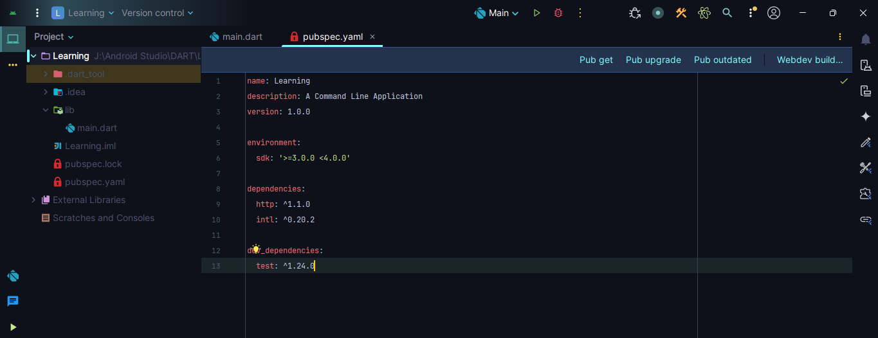
By that we successfully added intl Package in out Project. IF we check our pubspec File we will see now there is two dependencies. One is Http and Other one is intl.
That’s How we can add as many as package we want in our project.
In the next section we will see How we use that Package to work in our main.dart File.

5.3 Importing Libraries or Packages In Dart
In Dart Programming Language, we can use another person created Library or Packages From the pub.dev Website. To do that we must import their code to our code.
In Dart Programming Language, we use three places Library or Packages:
- Built-in Dart Libraries.
- External Packages (From pub.dev).
- Your own Project Files.

5.3.1. Importing Built-in Libraries
In Dart Programming, we use many Built-in Libraries like math Libraries For Mathematical Functions.
Now, math is a Built-in Library means this is created when the Language is created. So, IF we want to use that in our project we must import it to our code or main File. To do that we say:
import 'dart:math'; It Importing the math Libraries All File.
Now we can use the math Libraries Function in our code.

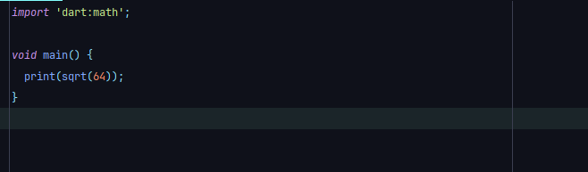
Example 1:

Here, in this example we First import the math Library then in the main Function we use a math Library Function name sqrt(number).
Here, the sqrt(number) take one parameters type integer and in the output, it returns the Square Root Of the Numbers as double data type.
So, this example prints 8.0.

5.3.2. Importing External Packages (From pub.dev)
We already see How to import a Library or Package. In our previous chapters we see we use pubspec.yaml File to download the External Packages For pub.dev websites.
We work with the same project we create in our previous chapters.

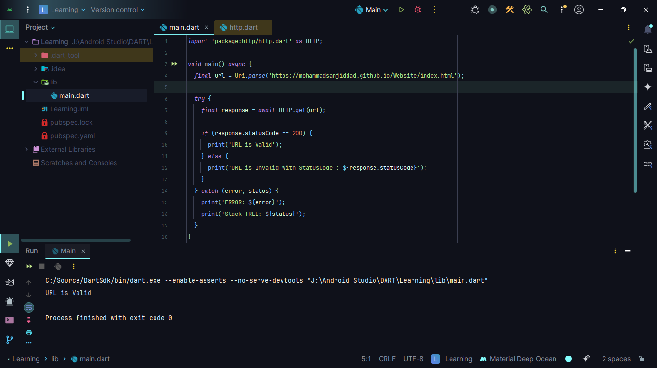
Example 1:
Here, in this example we First import the Package and say it should work as the name HTTP by typing as HTTP. Now, in the main Function we create a Final Variable name url. It checks that the website link is valid or not and returns some response.
In the next section we create another variable name response that await some time and give us the response credential then we check a condition IF (statusCode == 200) then print “URL is Valid”. Otherwise print “URL is Invalid”. Also, we do this in the try and catch Block For Healing Errors.

5.3.3. Create Our Own Custom Package or Library
In Dart Programming, we Have many ways to create a Custom Library or Package. In the earlier chapter we see How to create a project.
Package or Project create it by same way. There are not very much different.
We can create project by manually in the IDE or use this command,
dart create Application_name Create Dart Project
As For the Library or Package we can we can do the same as create by manually in the IDE or we can use this command,
dart create -t package Application_name Create Dart Package
First go to the location where we want to create the project then we open the terminal in that directory & pest the command.
Now, when we create the package by the command. Dart by default generates some Folders
Or some Code. The Project looks like,
My-Project/
|------- pubspec.yaml Package metadata.
|------- lib/
|------- My-Project.dart Main Entry Point For Package.
|------- src/
|------- operations.dart All Logic Or Code / Internal Logic
|------- test/
|------- My-Project-test.dart Dart Testing File to test All Code

Now, when we create it manually we Have to create all the Folder or the File one by one.
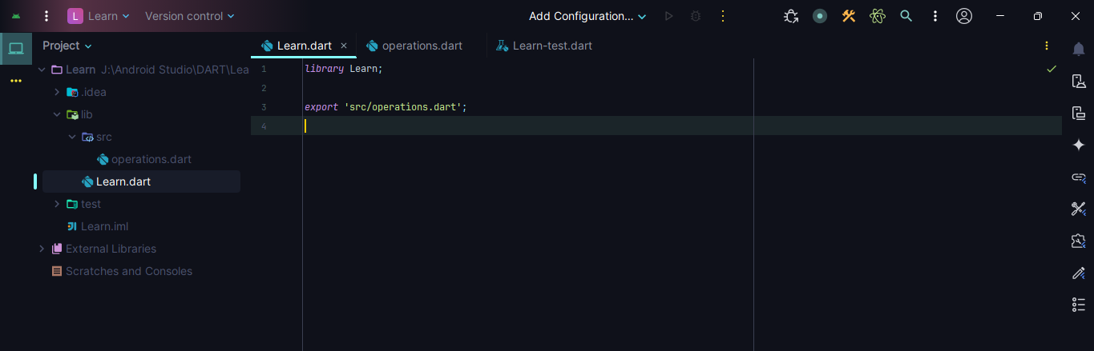
Now, in the entry point My-Project.dart File we right some code it is same in every Projects,
Here, in this example we create a project manually. We name this project Learn. Now, in the Lean project we create lib, src, test Folder & inside the lib Folder we create src and the Learn.dart File. Now, in the Learn.dart File we say that is a Library and we export the operations.dart File.

In Dart, the export keyword is used to Re-Export a Library File so that other Files Importing your Library gain access to everything inside the exported File.
Without needing to import it directly.
We export package’s main library File (Like lib/Learn.dart) to control what parts your package is exposed publicly.

Now, we done editing our Entry Point File. It’s time to edit our operations.dart File where we right our all Code or Logic.
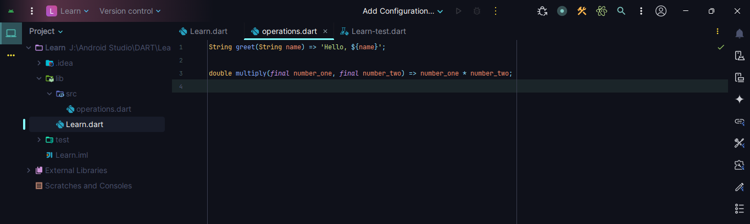
Now, in the operations.dart File we create two Functions. One is greet (name) that return a String. Other one, multiply (number_one, number_two) that return a double.
Now, We come close to Finish. There is one File left that is test File. We must test all our Functions or Logics after we use it in another projects.
Although we don’t learn the Dart Test yet. We learn this in our next upcoming chapters. As For now we can leave it as it is.
So, we complete our Custom Library Creation Chapter.
Dart Testing & Debugging

6.1 What Is Dart Testing
Dart testing is the process of writing and running automated tests to check that your Dart code works as expected. It helps catch bugs early, verify logic, and ensure your app remains stable when you make Changes.
Why Testing Is Important
- Catch Bugs Early.
- Ensure Code Behaves Correctly Over Time.
- Improve Code Quality and Confidence.
- Support Refactoring and Future Updates.
Dart uses the test package — Official testing Framework — For Writing and Running dart testing.

In Dart Programming we use 3 type testing,
- Unit Test. - Test Individual Functions/Methods.
- Widget Test (Flutter). - Test UI Components.
- Integration Test (Flutter). - Test Full user Flows.
In pure Dart Programming (non-Flutter), we mostly write unit tests.
In Dart Programming, we use testing in the Packages or Libraries to insurer there is no error. So, Here we create a Package then test the Functionality by using unit test.

6.2 Unit Testing In Dart
Unit tests are tests that check small pieces of code — usually individual Functions, Methods, or Classes — to make sure they work correctly.
First, we create our Library or packages. Here, we created named StringPackages. In the String package in the lib Folder we create a src Folder in the src Folder we create a Dart File name operations.
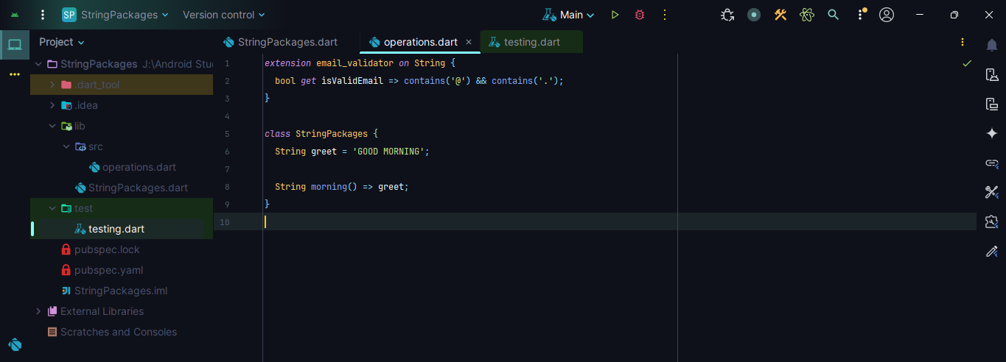
then right some code,
Here, we create an extension on String to Check that the given String is Email or not.

6.2.1. What Is test (), expect (a, m) Function In Dart Testing
To test our Functions one by one we use the test () Function. Inside the test Function use expect () Function.

Example 1:
import 'package:test/test.dart'; Import the test Packages.
import '../lib/StringPackages.dart'; Import our main Project File.
void main () {
test ('Check Is Email Valid', () {
expect ('SanjidDad@gmail.com'. isValidEmail, true);
});
}
Here, in this example we create a main Function then we use test () Function. Here, the test Function take 2 parameters, one is discerptions and the second one is a Function then it tests the Function is valid or not.
Inside the test Function we use expect Function that also take 2 parameters, one is the Functions or Logic and the second one is the result that Functions or Logic.
In this way we can test every Functions or Logic or Classes one by one.

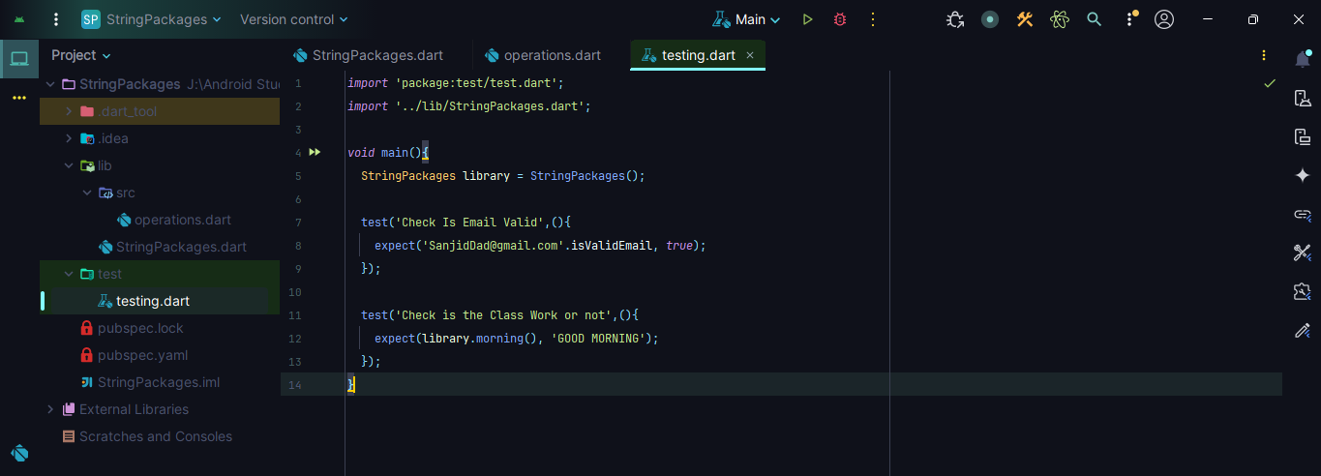
Example 2:
Here, we test the Class that contain Method name morning ().

6.2.2. What Is group (), setUp (), tearDown () Function In Dart Testing
Now, in this point we already use dart unit test. In the earlier Chapter we see we can test Functions or Classes Methods also. So, those are two different think one is under the Class one not.
Here, we can group those one by one. Example:
- One For Normal Functions.
- One For extension.
- One For Classes Methods.
So, to do that we use group Function so we can easily track them.
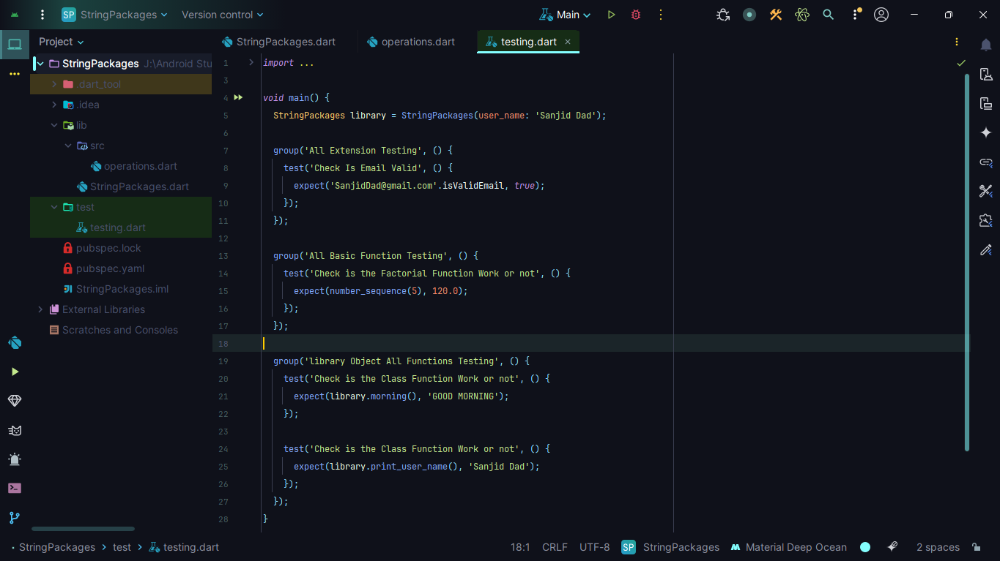
Example 1:
In this example we see almost all the testing Functions. We use two more Functions but those Function are not use like that. Those Functions are optional. Example:
- setUp () Function.
- tearDown () Function.

In Dart's testing Framework (using the test package), the setUp () Function is used to run setup code before each test case in a test suite.
It Runs before every individual test () in a group or File, Helps initialize shared Objects, Variables, or State Keeps your test Code Clean, Organized, and DRY (Don't Repeat Yourself).

The tearDown () Function is same as setUp () Function, one difference it run at the last.
6.3 Debugging In Dart
Debugging is the process of Finding and Fixing errors or bugs in your Dart code. Dart provides multiple tools and techniques For debugging both Dart and Flutter apps.
Some Common way to debug In Dart
Method | Description
print () | Simple, fast way to see values
assert () | Validates assumptions during dev
IDE Debugging Tools | Visual debugging with Breakpoints
DevTools | Advanced profiling (mostly for Flutter)

6.3.1. Print () Debugging (Quick & Easy)
Print is very good when we want to check something quickly. It is used to output small answers also it prints output only in the console or terminals.

Example 1:
void main () {
int a = 5; int b = 3;
int sum = a + b;
print ("Sum is: $sum"); Print the sum in the terminal.
}

6.3.2. Assert () (Only in Debug Mode)
Assert Function only used in the debugging mode. Its main purpose is to Check Condition. Ensure Conditions Hold true during development. IF the assertion Fails, Dart throws an error and the error will be the else Block Code.

Example 1:
void login (String? username) {
assert (username! = null, 'Username cannot be null');
print ("Welcome, $username");
}
6.3.3. Using dart devtools (Advanced)
In dart programming we usually don’t use dart devtools. We use it mostly in Flutter and web applications.
So, we don’t use it Here,
Features in devtools,
- Timeline performance.
- Memory usage.
- Network tracking.
- Widget inspector (Flutter).

Summary Table
Tool | Best For
Print () | Quick checks in console apps
Assert () | Validating logic in development
Breakpoints | Inspecting app state line-by-line
DevTools | Flutter debugging & profiling

THANK YOU

